

Republic of the Philippines

**MUNICIPALITY OF MATNOG**

Province of Sorsogon

**OFFICE OF THE MUNICIPAL AGRICULTURIST**

# OFFICE DESCRIPTION:

The Municipal Agriculture Office takes charge of the LGU’s **agricultural services** and in so doing performs the following functions:

(1) Formulate measures for the approval of the sanggunian and provide technical assistance and support to the mayor in carrying out said measures to ensure the delivery of basic services and provisions of adequate facilities relative to agricultural services as provided for under Section 17 of the Local Government Code;

(2) Develop plans and strategies and upon approval thereof by the mayor, implement the same, particularly those which have to do with agricultural programs and projects which the mayor is empowered to implement and which the sanggunian is empowered to provide;

(3) In addition the office has the following duties:

1. Ensure that maximum assistance and access to resources in the production, processing and marketing of agricultural and aqua-cultural and marine products are extended to **farmers, fishermen, local entrepreneurs, women and youth**;
2. Conduct or cause to be conducted location-specific agricultural researches and assist in making available the appropriate technology arising out of and disseminating information on basic research on crops, preventive and control of plant diseases and pests, and other agricultural matters which will maximize productivity;
3. Assist the mayor in the establishment and extension services of demonstration forms or aqua-culture and marine products;
4. Enforce rules and regulations relating to agriculture and aqua-culture;
5. Coordinate with government agencies and non-governmental organizations which promote agricultural productivity through appropriate technology compatible with environmental integrity;

(4) Be in the frontline of delivery of basic agricultural services, particularly those needed for the survival of the inhabitants during and in the aftermath of man-made and natural disasters;

(5) Recommend to the sanggunian and advise the mayoron all other matters related to agriculture and aqua-culture which will improve the livelihood and living conditions of the inhabitants; and

(6) Exercise such other powers and perform such other duties and functions as may be prescribed by law or ordinance;

# ROLES, DUTIES AND RESPONSIBILITIES

**MUNICIPAL AGRICULTURIST**

1. Monitor/Supervise of the implementation of agriculture and fishery programs and projects.

2. Monitor reports and submission of crop planting, harvesting and production; fish catch and fish culture production; and livestock production by assigned ATs.

3. Facilitate conduct of extension services, techno-demo and research/study on agri-fisheries to maximize production.

4. Formulate measures and develop plans relative agricultural services upon approval of the Mayors and the Sangguniang Bayan

5. Coordinate with other government agencies and non-government organizations for agri-fishery interventions that will benefits the local agri-fishery industry.

6. Exercise such other powers and perform such other functions as may be prescribed by law or ordinance.

**AGRICULTURAL TECHNOLOGIST**

Takes charge of the various agricultural and fishery banner programs and in so doing are responsible for the following:

1. Monitor production of existing production areas;
2. Help boost production to improve farmer/fisherfolk income;
3. Conduct Orientations, Trainings and Techno Demo to strengthen and mobilize organized farmers/fisherfolk groups and communities;
4. Make periodic reports on production, activities and programs with relation to agriculture and fisheries;
5. Facilitate the registration and masterlisting of farmers, fisherfolk, boats, fishing gears, livestock etc.

# FRONTLINE SERVICES

1. Technical Assistance and Management Services
2. Production Support and Distribution/Provision Of Farm Inputs/Fishing Paraphernalia, etc.
3. Enrollment of Farmers/Fisherfolk In The Registry System For Basic Sectors In Agriculture (RSBSA)
4. Fishing Boat Registration and Issuance of Permit to Operate (Including Renewals)
5. Issuance of License on Fishing Privileges (Including Renewals)
6. Issuance of Auxiliary Invoice

**PROGRAMS, PROJECTS AND ACTIVITIES (PPAs)**

***REGULAR PROGRAMS:***

1. **Rice Program** (AEWs assigned: Alyssa G. Sarmiento (P), Clara O. Garrido (JO) and Kc Lyn G. Enaje (JO))

* Palay Seeds distribution (Certified and Hybrid)
* Provision of Technical Assistance
* Distribution of other inputs (e.g. fertilizers)

1. **High Value Crop Development Program** (AEW assigned: Karen B. Antuerpia (P))

* Cassava and Corn Program
* Distribution of high-yielding variety planting (Lakan yellow and white, Hybrid Glutinous Corn)
* Provision of Technical assistance
* High Value Crop Production
* Distribution of vegetable seeds
* Farmers’ Field School
* Other input– Fertilizers and Garden tools
* Municipal Nursery (for Establishment)

1. **Fisheries** (AEWs Assigned: Ramil G. Gavarra (JO) and Gina Garcera (Jo))

* Maricuture Park Mgt.
* Fish cage for culture of Bangus, Grouper and Siganid
* Seaweed Culture
* Provision of Technical Assistance to Fisherfolks
* Marine protected Area/Fish Sanctuary Mgt.
* Seaborne Patrolling and Illegal Fishing Surveillance
* Bantay Dagat
* Sanctuary Guard
* Boat Registration

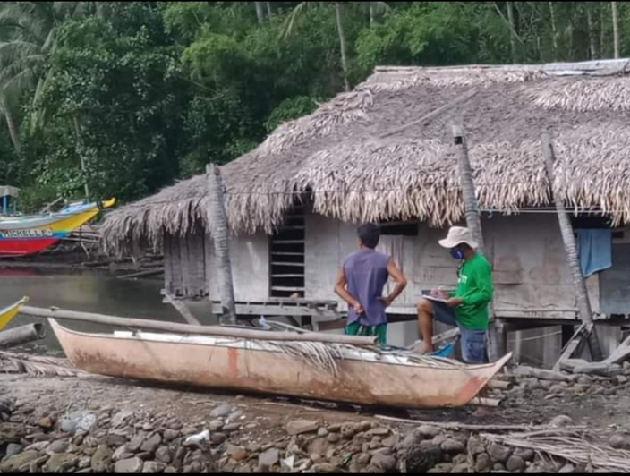

Boat Registration in Mambajog

* Monitoring of operation and maintenance of CFLC

1. **Livestock** (AEW assigned: Jerick L. Borjal (JO) and Redjie Gacis (JO))

* Dispersal/Redispersal
* Livestock Health Management
* Vaccination
* Provision of dewormers, vitamins
* Treatment services
* Livestock Trainings
* Establishment and operation of local quarantine checkpoints

1. **Institutional Development Program**

* Organization of Farmers, Fisherfolks, Women
* Assistance for registration (RSBSA)

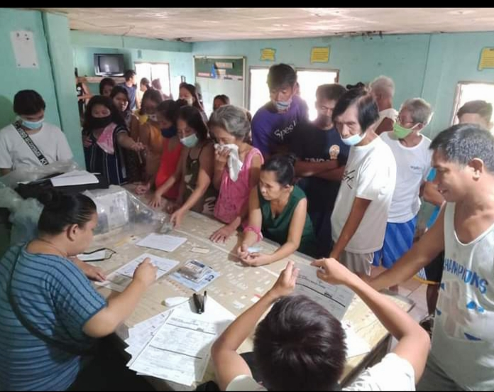

RSBSA Enrollment on Genablan Oriental

* Request/Provision of Livelihood Programs

***PROJECTS:***

**DA - RCEF**

* Provision of Palay Seeds (Hybrid and Certified)

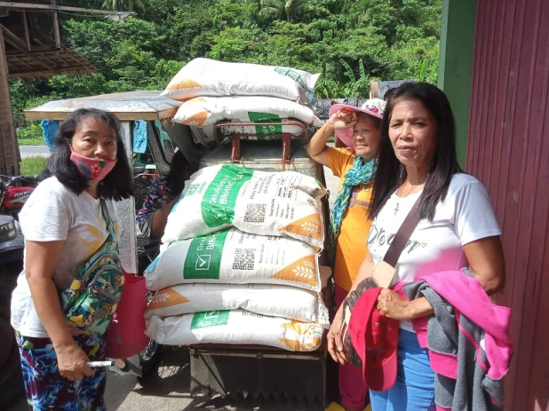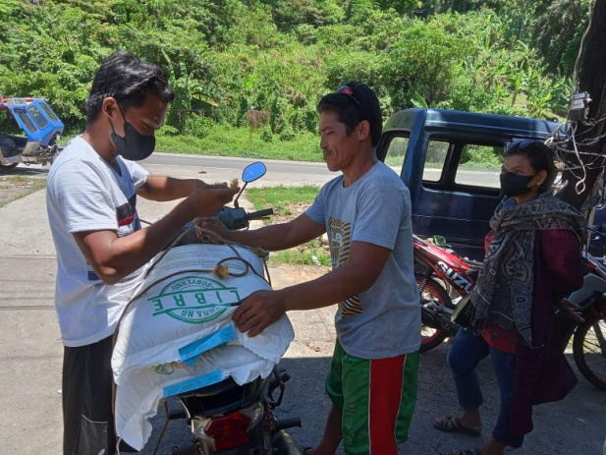

* Mechanization and provision of tools and equipments
  + 1 Mobile Rice Mill
  + 1 Four-Wheel Tractor
  + 4 Reaper
  + 3 Transplanter w/ Seedling Trays
  + 2 Floating Tiller
  + 7 Hand Tractor
  + 6 Thresher
* Technical Briefing

**PCIC**

* Provision of Crop Insurance

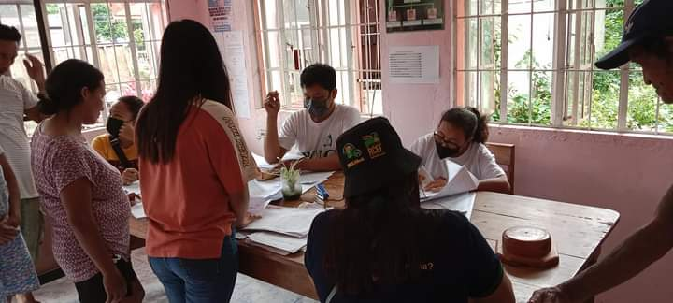

Crop Insurance Enrollment ion Brgy. Pawa

**DA - PRDP – GEF Sites**

* MPA Rehabilitation
* Support Facilities
* Training of Bantay Dagat
* Livelihood Program
* Seaweed Rehabilitation
* Grouper Production

**PAMANA - DA**

* **Livestock**
  + Provision/Dispersal of Mallard Duck (200+ heads – Municipal Wide)
* **Fisheries**
  + Seaweed Production (Calintaan-Mariculture Zone)
    - Provision of Collapsible Dryer and Mechanical Dryer
    - Provision of Training on Seaweed Produstion
    - Provision of inputs, tools and equipments

**DA - SAAD**

* **HVCC**
* Provision of Vegetable Seeds, Tools and Equipments (Banogao, Sisigon, Cabagahan, Pawa)
* Conduct of FFS on Vegetable Production

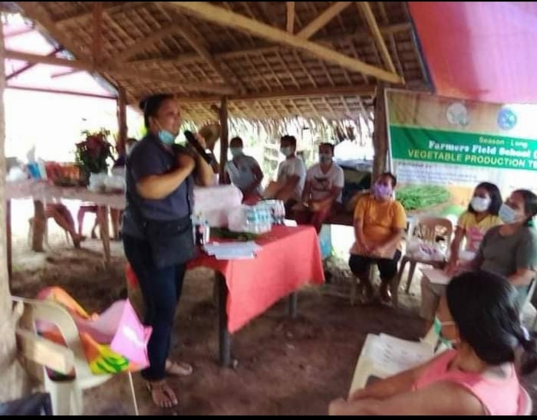

* Training on Value Adding/Food Processing for Vegetables(Banogao, Sisigon, Cabagahan, Pawa)
* Provision of Food Processing Tools and Equipments
* **Rice**
  + Provision on Certified Seeds and Fertilizer
  + Training of Value Adding/Food Processing for Rice

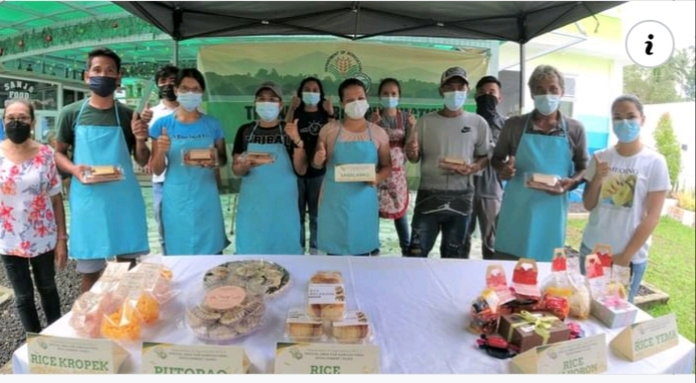

Food Processing for Rice @ Brgy. Hidhid

* + Provision of Tools and Equipment for Food Processing
* **Livestock**
  + Provision/Dispersal of Free Range Chicken (Bariis, Hidhid and Culasi)

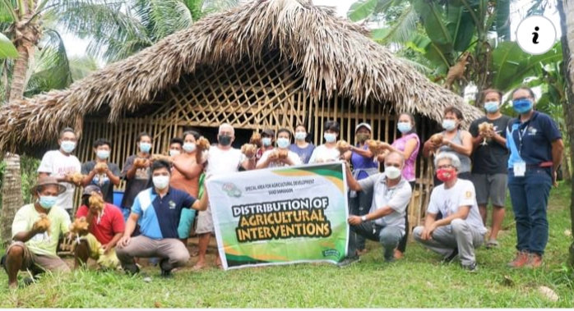

Dist of Free Range Chicken in Hidhid

* + Provision/Dispersal of Mallard Duck (Sta. Isabel)
  + Provision/Dispersal of Swine (Laboy)
  + Provision/Dispersal of Bovine (Culasi)
* **Fisheries**
* Provision of 2 units Motorboat with Drift Gillnet (Palutang - Sua)
* Provision of 2 units Motorboat with Drift Gillnet (Lawlawan – Genbalan Or.)
* Provision of Non-motorized Banca (Genablan Or.)
* Cage Culture of Grouper (Paghuliran)
* Cage Culture of Grouper and Bangus (Poropandan)

**PFO/BFAR**

* Provision/Distribution of Tilapia Fingerlings and Feeds
* Provision/Dispersal of Crab Entangling Net and Stationary Gillnet
* Aquasilvi Culture – Crab Production (Paghuliran)
* Crab Fattening (Naburacan)

**OPAG/DA RFO V**

* **HVCC**
  + Provision of Vegetable Seeds and Fertilizer
  + Provision of Farm Tools
  + Provision of tree seedlings (mango, rambutan, cacao, pili and calamansi)
  + Apiculture training and provision Inputs
* **Livestock**
  + Provision/Dispersal of Goat (Pawa)
* **Fisheries**
  + Training on Smoked Fish Processing
  + Provision of Smoke House and Tools – Sua, Coron-Coron and Genablan Oriental

**ELCAC**

* Provision of 50 Non-Motorized Banca and Fishing Paraphernalia (Bon-ot Small)

# LIST OF PERSONNEL AND STAFF

**PERSONNEL:**

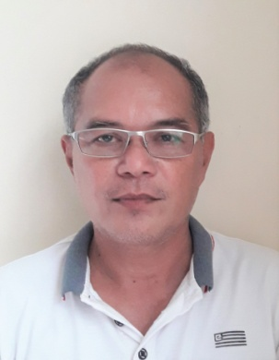

**EMMANUEL E. DEGUZMAN**

Municipal Agriculturist

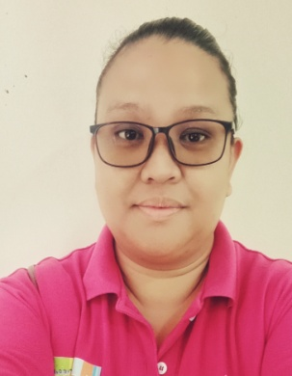

**KAREN B. ANTUERPIA**

Agricultural Technologist/AEW

HVCDP Coordinator

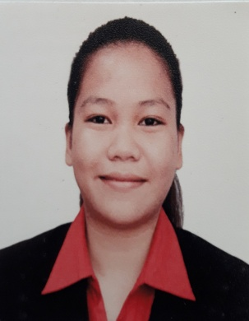

**ALYSSA G. SARMIENTO**

Agricultural Technologist/AEW

Rice Program Coordinator

**STAFF:**

**CLARA O. GARRIDO** - Agricultural Extension Worker (JO)

Rice Program Coordinator

**KC LYN G. ENAJE**  - Agricultural Extension Worker (JO)

Rice Program Coordinator

**JERICK L. BORJAL**  - Agricultural Extension Worker (JO)

Livestock Coordinator

**REDJIE GACIS** - Agricultural Extension Worker (JO)

**RAMMIL GAVARRA** - Agricultural Extension Worker (JO)

Fisheries Coordinator

|  |  |  |  |  |  |  |  |  |
| --- | --- | --- | --- | --- | --- | --- | --- | --- |
| **PROPOSED ADDITIONAL POSITIONS TO THE PLANTILLA** | | | | | | | | |
|  |  |  |  |  |  |  |  |  |
| **Item Number** | | **Position Title** | **Name of Incumbent** | **Current Year Authorized** | | **Budget Year Proposed** | | **Increase/ Decrease** |
| **Old** | **New** | **Rate/Annum** | | **Rate/Annum** | |
| **SG/Step** | **Amount** | **SG/Step** | **Amount** |
| **[1]** | **[2]** | **[3]** | **[4]** | **[5]** | **[6]** | **[7]** | **[8]** | **[9]** |
|  |  | Municipal Agriculturist | Emmanuel E. Deguzman | 24-1 |  | 24-1 |  |  |
|  |  | Municipal Agricultural Officer | Vacant (for dissolution) | 22-1 |  |  |  |  |
|  |  | Agriculturist II | Proposed |  |  | 15-1 |  |  |
|  |  | Agricultural Technologist | Karen B. Antuerpia | 10-5 |  | 10-6 |  |  |
| Alyssa G. Sarmiento | 10-1 |  | 10-5 |  |  |
|  |  | Agricultural Technologist | Vacant | 10-1 |  | 10-1 |  |  |
| Vacant | 10-1 |  | 10-1 |  |  |
|  |  | Aquaculturist I | Proposed (from item for dissolution) |  |  | 10-1 |  |  |
| Proposed |  |  | 10-1 |  |  |
|  |  | Agricultural Technologist | Proposed (from item for dissolution) |  |  | 10-1 |  |  |
| Proposed |  |  | 10-1 |  |  |

|  |  |  |  |  |  |  |  |
| --- | --- | --- | --- | --- | --- | --- | --- |
| **PROPOSED MODIFICATION TO THE ORGANIZATIONAL STRUCTURE (OMA)** | | | | | | |  |
|  |  |  |  |  |  |  |  |
| |  | | --- | |  | |  |  |  |  |  |  |  |
|  |  |  |  |  |  |  |  |
|  |  |  |  |  |  |  |  |
|  |  |  |  |  |  |  |  |
|  |  |  |  |  |  |  |  |
|  |  |  |  |  |  |  |  |
|  |  |  |  |  |  |  |  |
|  |  |  |  |  |  |  |  |
|  |  |  |  |  |  |  |  |
|  |  |  |  |  |  |  |  |
|  |  |  |  |  |  |  |  |
|  |  |  |  |  |  |  |  |
|  |  |  |  |  |  |  |  |
|  |  |  |  |  | Legend: | |  |
|  |  |  |  |  |  | |  |
|  |  |  |  |  |  | manned by permanent plantilla personnel |  |
|  |  |  |  |  |  | manned by JO worker |  |
|  |  |  |  |  |  | Unmanned |  |
|  |  |  |  |  |  |  |  |
|  |  |  |  |  |  |  |  |
|  |  |  |  |  |  |  |  |
|  |  |  |  |  |  |  |  |
|  |  |  |  |  |  |  |  |

**INTERVENTIONS NEEDED**

**Personnel**

* Establishment of the following OMA Units:
  + Regulation, Licensing, Data Management, Monitoring and Planning Unit
  + Operation, Production/Surveillance Unit
  + Research and Extension Unit
* Creation of 3 Agriculturist II with provision on Budget.
* Filling-up of 2 vacant AT I (SG-10) positions
* Dissolution of the MAO (SG-22) position and consequent creation and hiring of 1 Aquaculturist I (SG-10) and 1 AT I.
* Creation of 1 AT I and 1 Aquaculturist positions with provision of Budget for both.
* Detailment, Designation or Hiring of JO Facility Managers
* Provision of Trainings/ Capacity Building on the Administration and Management of various agri-fishery facilties
* Attendance to NC II Trainings, TOTs, Seminars and Conventions
* Provision of Trainings/Capacity Enhancement on Research and Technical Writing
* Benchmarking to Municipality within the province where RAFMES is being implemented successfully.
* Provision of Training on Basic Computer Operations and ICT to EAWs/FEWs
* Designation of Administrators for RSBSA, RAFMES, GEOAGRI, FFEDIS and other existing Agri-Fishery related Systems
* Conduct of Team Building cum mid-year/year-end Performance Review and Planning

**Facilities/Equipments/Supplies**

* Establishment of Municipal Plant Nursery
* Establishment of AA Slaughterhouse
* Procurement of animal biologics, supplies & equipment (endemic diseases)
* Procurement of vegetable seeds, fertilizers & tools

Submitted by:

**EMMANUEL E. DE GUZMAN**

MA